**Lab 4**

**Name : Deep Mehta, Rohit Phalke and Adwait Purao**

**UID : 2021300073, 2021300100 and 2021300101**

**Aim**: To crimp and test UTP cable.

**Objectives**: 1. To identify the specification of stripped through cable and its purpose. 2. To identify the pros and cons of patch cables over twisted pair cable.

**Do the following Cabling works in a network**

a) Cable Crimping

b) Standard Cabling and

c) Cross Cabling

d) IO connector crimping

e) Testing the crimped cable using a cable tester.

**Apparatus/Tools/Equipment/Components:**

• RJ-45 connector,

• IO Connector,

• Crimping Tool,

• Twisted pair Cable,

• Cable Tester.

**Theory:**

tester to test for proper continuity

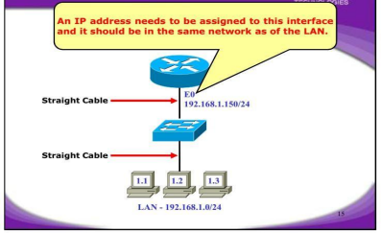

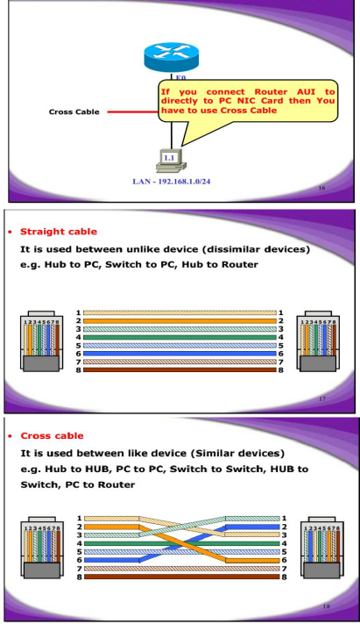

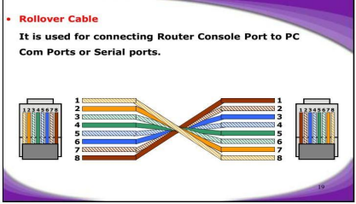

**Procedure:**

Cable Crimping steps:

1. Remove the outmost vinyl shield for 12mm at one end of the cable (we call this side A- side).

2. Arrange the metal wires in parallel

3. Insert the metal wires into RJ45 connector on keeping the metal wire arrangement. 4. Set the RJ45 connector (with the cable) on the pliers, and squeeze it tightly.

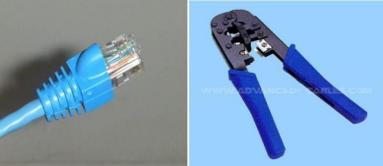5. Make the other side of the cable (we call this side B-side) in the same way.

6. After you made it, you don't need to take care of the direction of the cable.

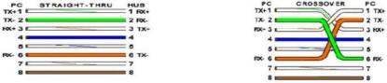

IO connector crimping: Run the full length of Ethernet cable in place, from endpoint to endpoint, making sure to leave excess.

At one end, cut the wire to length leaving enough length to work, but not too much excess. Strip off about 2 inches of the Ethernet cable sheath.

Align each of the colored wires according to the layout of the jack.

Use the punch down tool to insert each wire into the jack. Repeat the above steps for the second RJ45 jack.

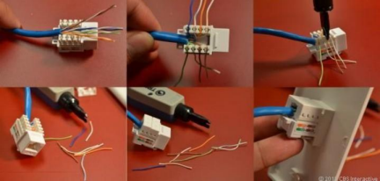

**Testing the crimped cable using a cable tester:** Step 1 : Skin off the cable jacket 3.0 cm long cable stripper up to cable

Step 2: Untwist each pair and straighten each wire 190 0 1.5 cm long.

Step 3 : Cut all the wires Step 4 : Insert the wires into the RJ45 connector right white orange left brown the pins facing up.

Step 5 : Place the connector into a crimping tool, and squeeze hard so that the handle reaches its full swing.

Step 6: Use a cable tester to test for proper continuity



**Questions**:-

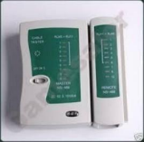

1. Which category cable is normally preferred for LAN and why? **ANS** : The Category 6 (Cat 6) cable is typically preferred for LAN (Local Area Network) installations. It offers higher performance compared to earlier categories like Cat 5 or Cat 5e. Cat 6 cables have more stringent specifications for crosstalk and system noise, which allows them to support higher data rates and bandwidths, making them ideal for modern LAN environments where high-speed data transmission is crucial.

2. Significance of each colour codes wires?

**ANS :**

1. White/Orange and Orange: Transmitting data (TX) - These wires carry data signals from the transmitting device.

2 .White/Green and Green: Receiving data (RX) - These wires receive data signals at the receiving device.

3 .White/Blue and Blue: Used for various purposes, including power over Ethernet (PoE) or for additional data channels in some Ethernet standards. 4 .White/Brown and Brown: Used for various purposes, including power over Ethernet (PoE) or for additional data channels in some Ethernet standards.

3. How many twists do you normally find in cat 5 5e and 6.

**ANS :** The number of twists per inch (TPI) in Ethernet cables like Cat 5, Cat 5e, and Cat 6 can vary, but there are general guidelines for each category: 1. **Cat 5**: Typically has 1.5 to 2 twists per inch.

2. **Cat 5e**: Generally has 1.5 to 2 twists per inch as well, similar to Cat 5. 3. **Cat 6**: Usually has more twists per inch compared to Cat 5 and Cat 5e, ranging from 2 to 2.5 twists per inch. This increased twist rate helps reduce crosstalk and interference, allowing for higher data transmission rates.



4. Latest version of patch cable available?

**ANS :** The latest version of Ethernet patch cables available is Cat 8. This category of cable supports data rates of up to 40 Gbps and is designed to meet the increasing demands of modern networks, especially in data centers and high performance computing environments. Cat 8 cables use the 8P8C modular connector (commonly known as RJ45) and are backward compatible with lower categories like Cat 6 and Cat 6a.

5. What's a roll over cable?

**ANS :** A rollover cable, also known as a "console cable" or "Cisco console cable," is a type of serial cable that is used to connect a computer or terminal to the console port of a networking device, such as a router, switch, or firewall.

The cable is called a "rollover" cable because the pinouts at each end of the cable are "rolled over" or reversed compared to a standard straight-through cable. This reversal allows the transmit pins of one device to connect to the receive pins of the other device, and vice versa, enabling two-way communication between the devices.

Rollover cables are commonly used for initial device configuration, troubleshooting, and accessing the command-line interface (CLI) of networking devices when direct access via a network connection is not possible or practical.

**Proof of Performance :**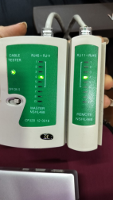



**Conclusion/Summary :**

1. Crimping and testing UTP cables is vital for secure and reliable network connections.

2. Proper crimping reduces the risk of network issues caused by loose connections.

3. Understanding cable specifications and types ensures the right cable selection for optimal network performance.

**References :**

**[1] How to Crimp and Test Network Cable :** https://www.youtube.com/watch?v=2RZEMvsg02I